Practical - 9
Practical Title: Secure User Registration with Database Insert, Duplicate Email Check, and Password Hashing

Implement secure user registration by inserting user details into MySQL
using MYSQLi. Validate input on frontend and backend, check duplicate
email/username, hash passwords using password_hash(), and display
appropriate messages.

Theory
1. Is password_hash() used before storing passwords?
Yes, password security is handled by applying hashing functions before saving user passwords to the database to prevent storing plain text.
2. Is duplicate email/username checked?
Yes, duplicate registration checks are integrated into the database logic using unique column constraints to ensure each email remains unique.
3. Are frontend and backend validations consistent?
Yes, both layers work in tandem—frontend JavaScript checks field formats instantly on submission while backend validation ensures received inputs meet criteria before database insertion.

Output
- Applied secure password processing methods to ensure credentials are safely encrypted before database persistence.
- Configured validation logic to verify student records and prevent duplicate entry submissions.
- Aligned client-side JavaScript validation rules with server-side PHP processing for complete end-to-end data integrity.

To View Code: https://github.com/shreyajodhani/studenthub.git

Evidence of Work (Screenshots)

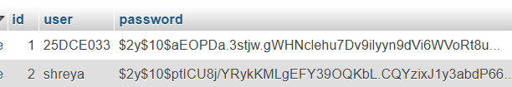
Description: Password stored after hashing in database

GitHub Repository Link: https://github.com/shreyajodhani/studenthub.git

Challenges Faced:

To stop user enter duplicate email

Learning Outcomes:
Learnt hashing.
Faculty Remarks: (Keep this blank for faculty)

